Introduction to Minorthird:
Getting Started Tutorial

Part I: Installing Minorthird

Before you can download minorthird, java and ant must be installed. Java can be found at http://java.sun.com. Make sure that you download and install the SDK. Ant can be downloaded at http://ant.apache.org .

Once you have downloaded both java and ant: (Note: Directions on how to do the following are below under “Setting Environment Variables”)
- Define JAVA_HOME
- Define ANT_HOME
- Add $JAVA_HOME/bin and $ANT_HOME/bin to your PATH

Setting Environment Variables (including your PATH)
Windows:
- Follow: Start → Settings → Control Panel
- If you are using Windows XP, click on Switch to Classic View on the left
- Double click on System
- Click on the Advanced tab
- Click the Environment Variables button near the bottom
- The top box should be labeled user variables and there may or may not be a variable already labeled PATH, JAVA_HOME or ANT_HOME. If the variable you are looking for is already there, highlight it and click Edit; otherwise click New, and add the variable name and location.
- Add the complete path of your java bin and ant bin to your PATH separated by semicolons. Your addition should look something like this: JAVA_HOME\bin;ANT_HOME\bin

Linux (Cygwin):
Type these commands:
- % export JAVA_HOME=c:/j2sdk1.4.2_04 (or wherever you put it)
- % export ANT_HOME=c:/apache-ant-1.6.1 (or wherever you put it)
- % export PATH=$JAVA_HOME/bin:$ANT_HOME/bin:PATH

Anyone can download minorthird using either sourceforge or CVS. Downloading from sourceforge requires less setup and is a little easier to get working. However the version of minorthird on sourceforge is only updated every one to two months and must be downloaded completely each time up want to update. I recommend the sourceforge version to people who do not have time to set up and are not familiar with CVS and are not interested in updating every week. CVS is good for people who already understand CVS, want to update frequently, and are possibly interested in submitting some changes.

Downloading from sourceforge:
- Go to: http://sourceforge.net/projects/minorthird/
- If you would like to look at all the source code, click on the regular minorthird source tree. For faster downloading and set up, click on minorthird-jar. Important: you will not be able to view source code or make changes if you only download the jar.
- Click on either the zip file or the jar file that you would like to download.

Downloading from CVS:
Note: If you would like to submit changes to minorthird email William Cohen, wcohen@cs.cmu.edu, and Cammie Williams, cammie@cmu.edu, to get a personal account on raff.
- Download CVS, we suggest using tortoise CVS, which can be obtained at http://www.tortoisecvs.org/. (If you are using cygwin, make sure to add CVS to your path and that ssh is installed. Note: ssh is not installed under the default packages in the cygwin setup, it is suggested that you install all cygwin packages.)
- Move to the directory you would like minorthird in
- Set these environment variables:
  - CVS_RSH=ssh
  - cvsroot=:pserver:anonymous@raff.cald.cs.cmu.edu:/usr1/cvsroot
- Type these commands:
  - cvs login
  - cvs checkout minorthird
  - cvs update –dP (the –dP is needed to remove deleted-from-cvs files and directories)
- Alternatively you can type:
  - Export CVS_RSH=ssh
  - cvs –d :ext:anonymous@raff.cald.cs.cmu.edu:usr1/cvsroot checkout minorthird
- The minorthird source tree should appear in your current directory.

Running Minorthird
- Set the MINORTHIRD variable
- cd to MINORTHIRD
- Run the setup script which sets you classpath:
  - In Windows type: script\setup
  - In Cygwin type: source script/setup.sh
  - In Linux type: source script/setup.linux
- To compile the code type:
  - %ant build-clean
- To compile the javadocs type:
  - % ant javadoc
- To run the tests to make sure things are working type:
  - % ant tests

Part II: The Basics and Labels

MinorThird is a collection of Java classes for storing text, annotating text, and learning to extract entities and categorize text. While there are several packages for using Minorthird in this tutorial, we are first going to explore the UI package.

Find out what you can do in the UI package by typing:
% java –Xmx500M edu.cmu.minorthird.ui.Help

This command will print a list of the programs you can run using Minorthird. To get more detail about each program and its parameters, you can type:
% java –Xmx500M edu.cmu.minorthird.ui.[programName] -help

Every program you can run in Minorthird requires and dataset. Datasets can contain labels, which can be stored in either a labels document or embedded in the document in the form of XML tags. Labels are applied to spans, which are series of adjacent tokens that can range in size from a single token to an entire document.

Example of text labels in a labels document:
addToType afp+20040521+germany_internet_spam 184 3 extracted_date
addToType afp+20040521+germany_internet_spam 189 11 extracted_date
addToType afp+20040525+stocks_us_ge_genworth 205 3 extracted_date

In a labels document the second word is the document name, the third word is the starting token of the span, the fourth word is the length of the span, and the last word is the label.

Example of a document with embedded labels:
<title>German gov't probing surge in spam e-mails (AFP)</title>
<link>http://us.rd.yahoo.com/dailynews/rss/spam/*http://story.news.yahoo.com/news?tmpl=story2&u=/afp/20040521/tc_afp/germany_internet_spam</link>
<pubDate>Fri, 21 May 2004 13:38:17 GMT</pubDate>

In this type of document a labeled span lies between the < > and </ > markers. The label is the word between the marks.

To get a better feel for what is happening in Minorthird, you can look at the javadocs. To construct the javadocs type: % ant javadoc. Also an older version of the docs are on William’s website or on http://minorthird.sourceforge.net/

Notes:
- what you are able to mark up is defined by TextLabels API
- spanTypes are the "most central" construct, and tokenProps and others not as well supported (saving, viewing, etc)
- the metaphor is that the toolkit is a programming language for annotations.
  - As a programming language, need subroutines and libraries, which are invoked textLabels.require(), return output by adding annotations, and completion/status information in textLabels.isAnnotatedBy().

We are going to use the sample dataset small-newsdir for this tutorial. This dataset is labeled with XML tags. This dataset can be found on William’s website (http://wcohen.com) under Teaching, Slides, notes, and materials for day 1. To look at the documents and labels in the small-newsdir dataset type:
% java –Xmx500M edu.cmu.minorthird.ui.ViewLabels –labels small-newsdir

After a few seconds, a window like this will appear:
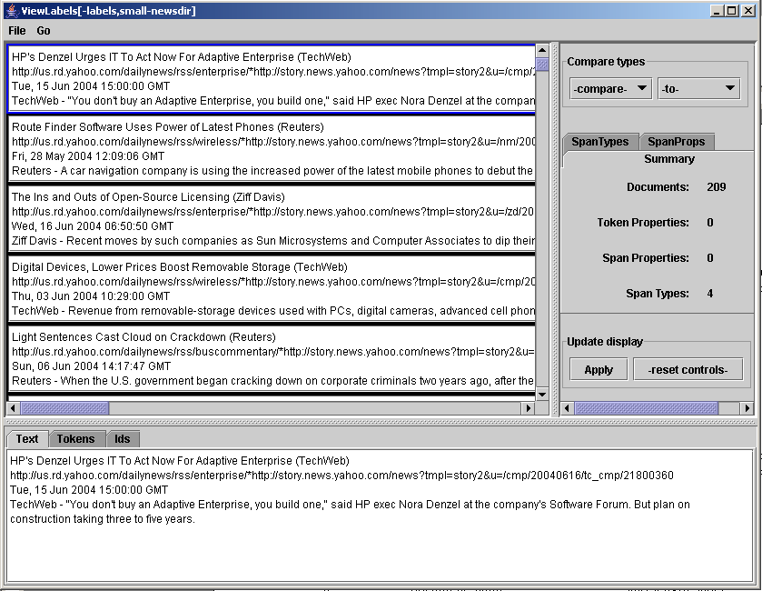

You can expand the window by clicking and dragging and corner and you can expand or shrink an section by clicking and dragging the section dividers. To see how each document has been labeled, click on the SpanTypes tab in the upper right section of the window. Now the upper right section of the window will look like this:
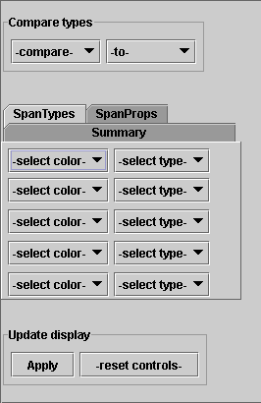
Click on the –select color- menu to select a color for highlighting and click on the –select type- menu to choose a label you would like to highlight. Make sure to highlight different labels in different colors. Click the Apply button at the bottom of the section to view this highlighting.

To view an entire article, click on the article in the upper left section. The article will appear in the lower section. To see the complete text of an article choose the text tab in the bottom window and to see the token of the article click on the tokens tab.

Part III: Mixup

Minorthird’s language for manipulating text is mixup (Minorthird Information eXtraction and Understanding Program.) Sample mixup programs can be found on William’s website (http://wcohen.com) under Teaching, Slides, notes, and sample files from the first day’s lecure. Here is a sample program (sample1.mixup) with commentary:

defSpanType source1 = title: ... '(' [ ... ] ')' ;

In this line of mixup, defSpanType source1 defines source1 as the spanType which is defined to the right of the equal sign. The expression to the right of the equal sign defines the pattern where source1 can be identified. This line expresses that source1 is in the title between the parentheses. Here is a list of what each part of the expression means:
defSpanType - keyword
source1 - name of the defined spanType
title: - start with title and match to the pattern defined in the
remainder of the expression
… - anything
‘(‘ - the left parenthesis token
[ - START
… - anything
] - END
‘)’ - the right parenthsis token

defSpanType source2 = description: [ !'-'+R ] '-' ... ;

This line of mixup is very similar to the line above, but contains a few new expressions:
! - not this token
+ - 1+ times
R - Extend to the right

To see the parameters for running a mixup program type:
% java –Xmx500M edu.cmu.minorthird.ui.RunMixup –help

Now lets try running a sample mixup program. To do this make sure the sample programs are in you minorthird/lib/mixup directory. Try:
% java –Xmx500M edu.cmu.minorthird.ui.RunMixup –labels small-newsdir –mixup sample1.mixup –showResult
- The –showResult parameter will graphically display the output
OR
% java –Xmx500M edu.cmu.minorthird.ui.RunMixup –labels small-newsdir –mixup sample1.mixup –gui
- Press the “Start Task” button to run the program

When the program is done running a window like this will appear:
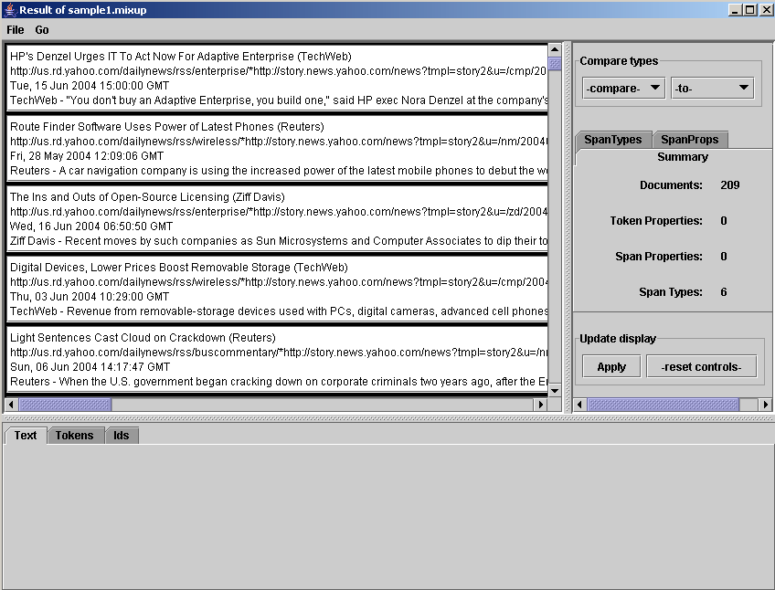

This window looks similar to the one that appeared when you ran View labels; however, you will notice that there are now 6 span types rather than 4 since sample1.mixup defined two more span types: source1 and source2. To see what the mixup program extracted, try going to the SpanTypes tab and highlighting source1 and source2.
Sample1a.mixup demonstrates what happens if a mixup expression contains + instead of +R. Unlike other languages which extend patterns greedily, mixup takes each pattern literally and backtracks as needed. To see how this works run:
%java –Xmx500M edu.cmu.minorthird.ui.RunMixup –labels small-newdir –mixup sample1a.mixup –showResult –saveAs foo.labels

Note: -saveAs FILE means save as some computer –readable format, and it works for most ui programs.

When the window appears, highlight source2s. Knowing the source2 is any prefix that ends before a ‘-‘, you can see how this does not work right. Now try running sample1.mixup again and see how it does work right with the +R rather than just the +.

The lessons from these two sample mixup programs are:
- Use L and R prefixes for expressions that can match, when you can
- Use non-determinism when you need to
  - Ex: defSpanType bigram =description: ... [any any ] ... ;

Another example: sample2.mixup – take a look then run:
% java -Xmx500M edu.cmu.minorthird.ui.RunMixup -labels small-newsdir -mixup sample2.mixup –showResult

Now lets take a look at some annotators:
- Open sample3.mixup (don’t look at it yet)
- Run: java –Xmx500M edu.cmu.minorthird.ui.RunMixup –labels small-newsdir -mixup sample3.mixup –showResult
  - This will take a while…
- Now take a look at sample3.mixup
  - ‘require’ asks for some type of annotation
  - Annotators are found usually in $MINORTHID/lib/mixup
  - Annotators can be re-defined in “annotators.config” which is usually in $MINORTHIRD/config/annotators.config
- When RunMixup is finished running, we will save the computation to save time later on. To do this, click the SaveAs button at the bottom middle of the top left window (you will have to scroll to get there.) Note: File->SaveAs does not work in this case, it is only for serializable objects.
- Now pick out some useful tags and save them in small-newsdir.labels
% perl -ane "print if $F[4]=~/(description|year|title|source|pubDate|link|extracted|contentArea|body|NP|Name|NNP)/" sample3.labels | grep addToType | cut -d" " -f5 | sort | uniq -c
% perl -ane "print if $F[4]=~/(description|year|title|source|pubDate|link|extracted|contentArea|body|NP|Name|NNP)/" sample3.labels > small-newsdir.labels
% java -Xmx500M edu.cmu.minorthird.ui.ViewLabels -labels small-newsdir

Note: To find labels for –labels FOO(1) look in repository (2) look for directory FOO (3) look for FOO.labels for markup, and ignore in-line markup

Part IV: The Mixup Debugger and LabelEditor

Debugging Mixup gives you the ability to edit your labels and your labeling program in parallel. To see how this works, copy saved-handLabeled.labels to handLabeled.labels and try:

% java –Xmx500M edu.cmu.minorthird.ui.DebugMixup –labels small-newsdir –edir handLabeled.labels –mixup sample5.mixup

A window that looks like this will appear (without the highlighting at first)
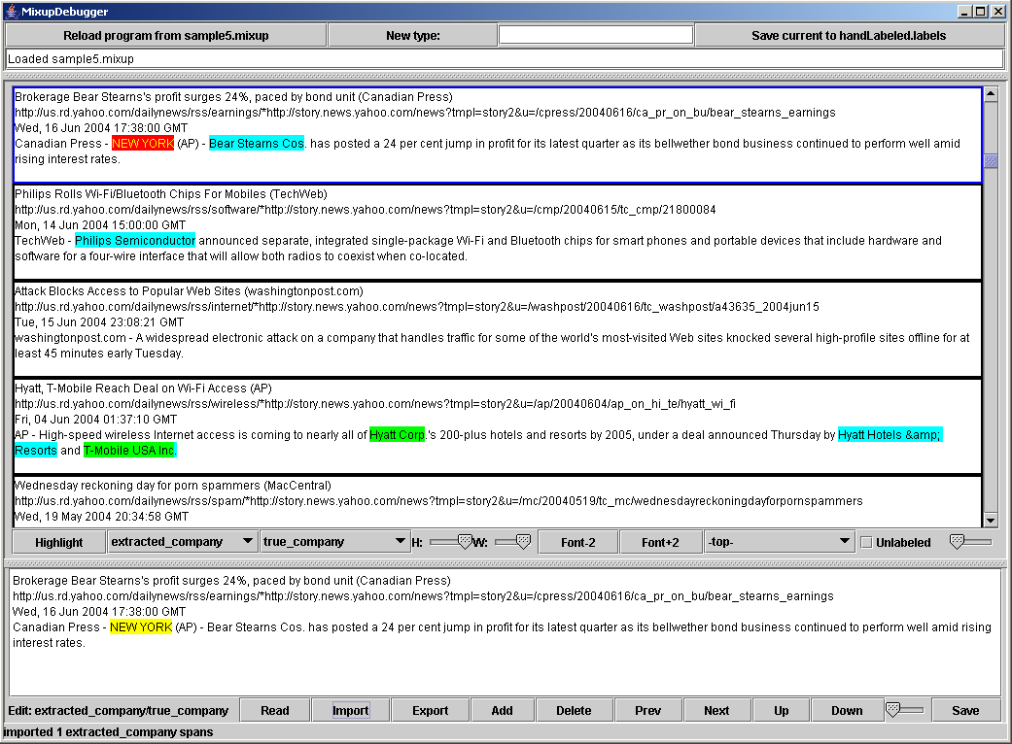

To highlight extracted companies (which were defined by the mixup program), select extracted_company from the first pull down menu on the section divider. All the extracted companies will turn yellow (you may have to scroll down a little to find any.) Then to view the true companies, which were defined by handLabeled.labels, select true_company from the second pull down menu. All hand labeled companies that were properly extracted by the mixup program will turn green, all companies that were missed by the mixup program will turn blue, and false positives will turn red. (See above picture for reference.)

To edit the labels, click on a document, and click the Import button at the bottom of the window. This will import all the extracted company labels. To correct these labels click the Next button and Delete if it is a false positive. To add a label, highlight the span and click Add. When you are finished labeling a document, click Export. Click save when you finish.

Some Tricks:
- On RHS of the center bar, replace -top- with -body- to focus the window to what you care about.
- Replace -top- with -extracted company- and move the slide to look for extractions-in-context.

When you're close enough with the debugging, you might want to hand
the task over to someone else to get more training data. First run the
current program:

% java -Xmx500M edu.cmu.minorthird.ui.RunMixup -labels small-newsdir -mixup sample5.mixup -saveAs sample5.labels

Now take the relevant part of its output, and your hand-labeling results,
and merge them:

% grep extracted_company sample5.labels > labelingTask.labels
% cat handLabeled.labels >> labelingTask.labels

Now run the labelling tool (which is somewhat stripped down, probably
not enough), on the result:

% java -Xmx500M edu.cmu.minorthird.ui.EditLabels -labels small-newsdir -edit labelingTask.labels -extractedType extracted_company -trueType true_company

Part V: Extraction Learning

Now that you are done labeling some data, you can try running an extraction experiment with the data that you have created. You can view the labels that you have created by concatenating all the labels your have saved in the file small-newdir.labels and running:
% java –Xmx500M edu.cmu.minorthird.ui.ViewLabels –labels small-newsdir

Note: If minorthird is not loading the labels file check that your labels file is exactly the same as the name of the data directory with .labels appended to the end. Also, make sure that your labels file is in the same directory as you data directory.

This should look a lot like what was in the label editor. Now lets try learning from the data:
% java –Xmx500M edu.cmu.minorthird.ui.TrainTestExtractor –gui

Note: Almost all the ui tools support the –gui option, which allows you to explore what is possible to do. However, this graphical user interface is not yet quite ideal to use.

There are a lot of defaults for a TestTrainExtractor experiment, but you need to at least specify where the data is and what you want to learn. You can do this in the gui by:
- Follow: Edit → baseParameters → labelFilename and hit Browse and select the small-newsdir directory
  - 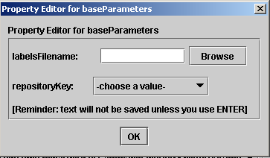
- Close all these windows with “oks”
- Now that you have specified the data, you can click the Show labels button, which should bring up a window similar to the one you saw when you ran ViewLabels. Verify that the data is correct.
- Follow: Edit → signalParameters → spanType and select true_company (what to learn)
  - 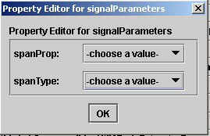
- Follow: Edit → splitterParameters and check “showTestDetails” for more output for debugging
  - 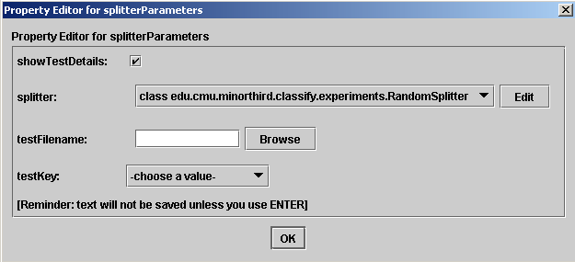
- Follow: Edit → trainingParameters → learner and check displayDatasetBeforeLearning
- Hit “Start Task” Button… the evaluation will take a minute or two

The SequentialDataset window is what Minorthird reduces the extraction
problem to: POS/NEG examples for each word, depending on whether or
not it's in the select spanType.

Expected result: SpanPrecision: 0.5000 SpanRecall: 0.0132 F: 0.0256

This pretty terrible....to see what was learned, since we checked "showTestDetails",
we can see the classifiers for POS/NEG words.

To do this in the gui:
Hit "View Results" → "Annotator 1" and a window like this will appear:

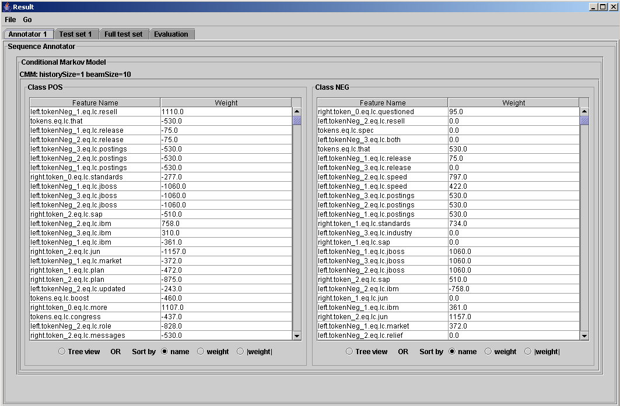

To see the results of this experiment in the gui, click the Evaluation tab. To see a visual representation of the results, click on “Full test set” tab. Click on the –compare- pull down menu and select true_company. Next click on the –to- pull down menu and select _predicted (or whatever you names the learned output.) Next click the apply button. The results should look something like this:

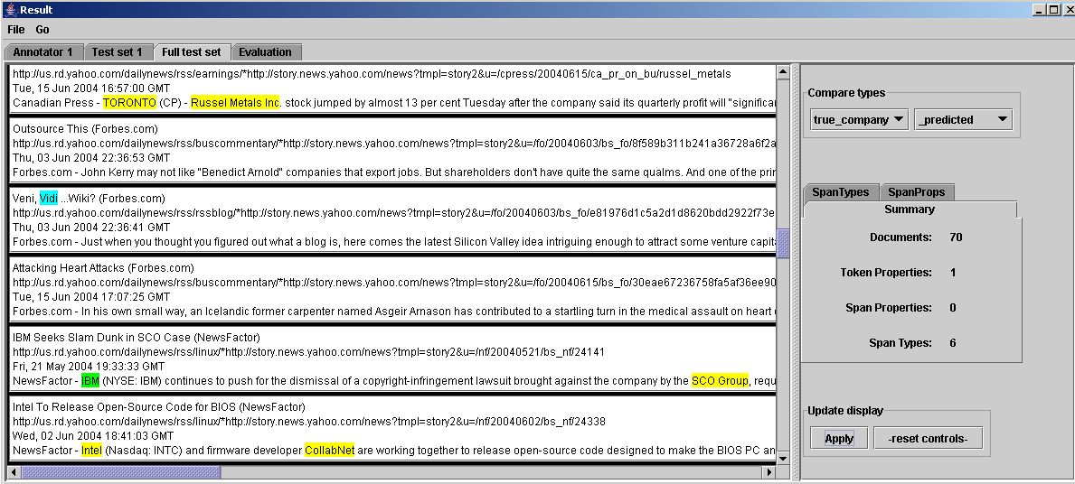

As you can see, there is a lot of yellow highlighting, which means the learner did not predict a company name when it was supposed to. Blue is a false positive and green is a true positive. The learner seems to have learned stuff like "IBM" and "SCO" as well as stuff like "inc", capitalization, etc, which make sense.
What can we do to improve matters? One way is to tweak the learner, for example:
- Follow: "edit" → trainingParameters → learner → sequenceClassifierLearner and choose 10 epochs
  - 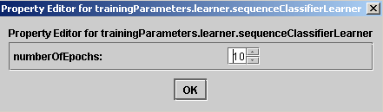
- Follow: "edit" → trainingParameters → learner → sequenceClassifierLearner and set history=3
  - 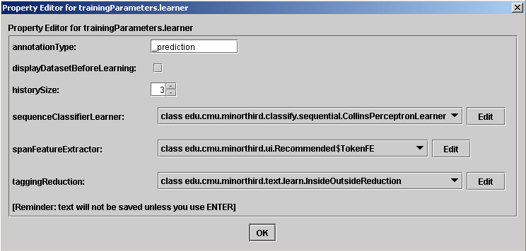
- Follow: "edit" → trainingParameters → learner → sequenceClassifierLearner → spanFE and set featureWindowSize=2
  - 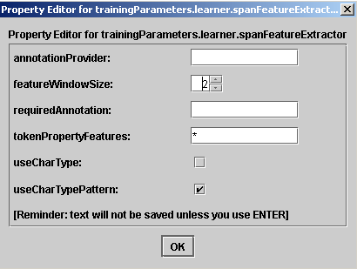
- Follow: "edit" → trainingParameters → learner → taggingReduction and choose BeginEnd...Reduction
  - 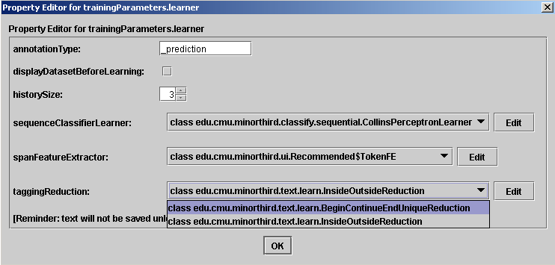

Note that learning is in steps: picking a mapping from text to names, picking a class for extracting features from words, picking a learning algorithm. You can look at the code and/or javadocs for the feature extractor to see exactly what's happening.

To see the difference in the reduction, look at the SequenceDataset that pops up.

About 2min of grinding gets: SpanPrecision: 0.67 SpanRecall: 0.19 F: 0.30

Recalling the architecture of Minorthird: another way to tweak performance is to add some more background information with a mixup file. Minorthird will run the mixup before extracting features (by "requiring" the annotation type sample5a) and use all TokenProperties as features.

The *required* change from the labeling program is to add "provide sample5a" at the top. The "optional" changes are to export "interesting" stuff as TokenProperties.

Follow "edit" → trainingParameters → mixup => sample5a.mixup

Warning: this is passed in to the feature extractor, and it's tricky, so it's worth checking that it was done right. Sometimes the list of importable properties isn't updated.

Follow "edit" → trainingParameters → learner → spanFeatureExtractor → tokenPropertyFeatures => *

This gets us to SpanPrecision: 0.60 SpanRecall: 0.23 F: 0.33

Let's look at what was learned:
"View Results" → Annotator 1

Or sample6.mixup has more stuff in it, including POS tags and other stuff that seemed like it might be useful, and some old dictionaries of company names that were lying around. This is also a "safer" file than sample5a, because sample5a assumes the existence stuff like 'pos' that we manually saved in the labels file. (If you ran it without that manual preprocessing, it would break.)

- Follow "edit" → trainingParameters → learner → sequenceClassifierLearner => 20 epochs
- Follow "edit" → trainingParameters → mixup => sample6.mixup

Notice that this starts out running the POS tagger - that's the "safety" issue I told you about. 20 iterations is a lot…

Gets us to SpanPrecision: 0.6471 SpanRecall: 0.3385 F: 0.4444

Log shows that the learner didn't converge with the latest feature set, which suggests even more iterations. More training data is also nice...

- Follow "edit" → splitingParameters → splitter → CrossValidationSplitter

gets us to: SpanPrecision: 62 SpanRecall 66 F1: 64
and token-level F1 is about 78, so many partial matches

For reproducibility, some of this parameter setting can be done on the command-line, and plan is to make all of it command-line settable soon.

% java -Xmx500m edu.cmu.minorthird.ui.TrainTestExtractor -labels small-newsdir -spanType true_company -mixup sample6

We can also put these parameters in a file, say expt1.config

labels=small-newsdir
spanType=true_company
mixup=sample6
saveAs=expt1.eval

Then run the experiment with:
% java -Xmx500m edu.cmu.minorthird.ui.TrainTestExtractor -config expt1.config

- Follow "edit" → additionalParameters → learner → sequenceClassifierLearner => 20 epochs
- Follow "edit" → additionalParameters → learner → taggingReduction => BeginEnd...Reduction

Saving a learned extractor:

All this is just experimentation. Suppose you want to actually build a new extractor and run it on unlabeled data?

I'll illustrate with default learner and sample5, to save for time.
To build the classifier.
% java -Xmx500m edu.cmu.minorthird.ui.TrainExtractor -labels small-newsdir -spanType true_company -mixup sample5a -saveAs orgName.ann

Then to apply it:
% java -Xmx500m edu.cmu.minorthird.ui.ApplyAnnotator -labels newsdir -loadFrom orgName.ann -gui

Classification:

Sample task: construct features for "email acts". Example act: is an email messages a commitment (to do something)?

Learning for classifiers is similar to extractors. Here's performance for a VotedPerceptronLearner, similar to an SVM, where cmt.config has been prepared..

% java -Xmx500m edu.cmu.minorthird.ui.TrainTestClassifier -config cmt.config -saveAs vp.eval

Aside: often you want to weight bag of word, features, eg with TFIDF weight. To weight features, there is a package called classify.transform. We'll convert to TFIDF with an InstanceTransform constructed by an InstanceTransformLearner. To put this in front of the voted perceptron learner, we'll use a TransformingBatchLearner.
% java -Xmx500m edu.cmu.minorthird.ui.TrainTestClassifier -config cmt.config -learner "new TransformingBatchLearner(new TFIDFTransformLearner(),new Recommended.VotedPerceptronLearner())"

We looked at: word bigrams; the number of time expressions in a message; and the words that occurred near a time words appearing near a pronoun or proper noun; bags of part-of-speech tags. To do this "complicated" feature engineering, use the mixup emailActs.mixup, and the feature extractor EmailActFE.java. You need to compile EmailActFE and have the class file on your feature path, then you can do

% java -Xmx500m edu.cmu.minorthird.ui.TrainTestClassifier -config cmt.config -fe "EmailActFE()"

While that's running: the javadocs for text.learn.SpanFE define this "little language" of feature extraction. The names are kept short because the result is a set of features, each of which has a name that directly reflects the way it is derived.

To create a saved annotator, the following is recommended:
% java -Xmx500m edu.cmu.minorthird.ui.TrainClassifier -labels cspace.3f2 -spanType Cmt -saveAs cmt.ann -fe "EmailActFE()" -embed "EmailActFE.class;emailActs.mixup"

The obscure-looking -embed option takes these files and "embeds" them into the feature extractor, so that when the learned annotator is used, they don't still have to be on the classpath. The argument is a path (using the OS-local path separator).

BTW: If you want to make your hand-coded learners and/or feature extractors available in your gui, add their classNames to the file $MINORTHIRD/config/selectableTypes.txt

